|  |  |
| --- | --- |
|  | **HO CHI MINH UNIVERSITY OF TECHNOLOGY** **FACULTY OF TRANSPORTATION ENGINEERING** **DEPARTMENT OF AUTOMOTIVE AND ENGINE** |

**GRADUATION THESIS**

**STUDY ON AUTOMOTIVE PUSH-ROD**

**SUSPENSION SYSTEM**

|  |  |  |
| --- | --- | --- |
| |  | | --- | | STUDENT:  INSTRUCTOR:  DATE: | | Nhu Quoc Huy – ID: 1852412  Ph.D Tran Dang Long  June 15th 2022 |

**STUDY ON AUTOMOTIVE PUSH-ROD SUSPENSION SYSTEM**

CONTENTS

|  |  |  |
| --- | --- | --- |
| **1** | Introduction | 1 |
| **2** | Key problems |
| **3** | Implementation process |
| **4** | Result and disscussion |
| **5** | Conclusion and future work |
| Ho Chi Minh University of Technology – 2022/05 |



**STUDY ON AUTOMOTIVE PUSH-ROD SUSPENSION SYSTEM**

CONTENTS

|  |  |  |  |  |
| --- | --- | --- | --- | --- |
| |  | | --- | | **1** | | **Introduction** | **1.1** | Suspension system |
| |  | | --- | | **2** | | Key problems | **1.2** | Suspension components |
| |  | | --- | | **3** | | Implementation process | **1.3** | Technical characteristics |
| |  | | --- | | **4** | | Result and disscussion | **1.4** | Thesis objectives & limitations |
| |  | | --- | | **5** | | Conclusion and future work | |  |
|  | Ho Chi Minh University of Technology – 2022/0 | | 2 |

|  |  |  |
| --- | --- | --- |
| **1. INTRODUCTION**  Suspension system | **1.1 Suspension system** | |
| Rocker arm | **Suspension system:** connects the wheels to vehicle body,  allows relative motions. |

**Primary function of the suspension system:**  
• Isolating the roughness between road and the vehicle

chassis

|  |  |  |  |
| --- | --- | --- | --- |
| Push-rod | Vehicle’s wheel | • Keep the wheel in proper position (wheel alignment)• Stable in rapid cornering without body roll • Keep the tires in contact with the road surface • Support the weight of the vehicle | |
| *Fig 1: Push-rod suspension system* | |
| Ho Chi Minh University of Technology – 2022/05 | 3 |

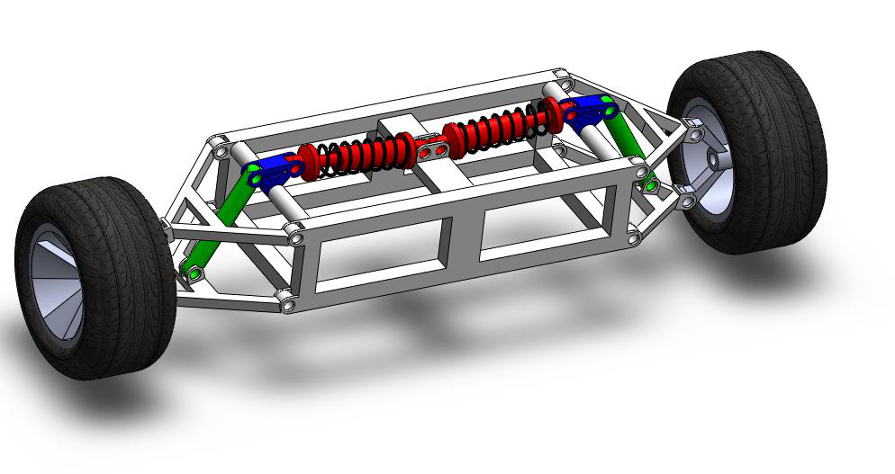

|  |  |  |  |
| --- | --- | --- | --- |
| **1. INTRODUCTION** | **1.2 Suspension components** | |  |
| **Elastic elements** | | **Damping elements** | **Linkage** |
| **(Coil spring)** | | **(Shock absorber)** |

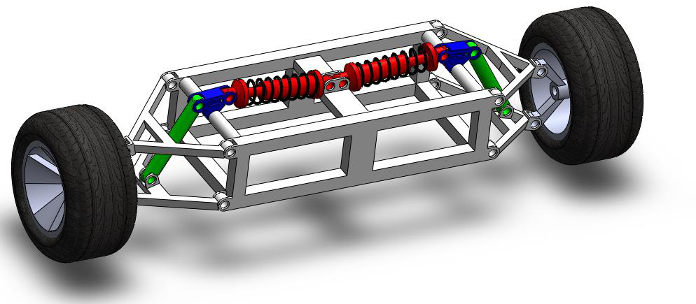

*Fig 2: Push-rod suspension system components*

|  |  |  |
| --- | --- | --- |
| |  | | --- | | Ho Chi Minh University of Technology – 2022/05 | | 4 |

|  |  |  |  |  |
| --- | --- | --- | --- | --- |
| **1. INTRODUCTION** | **1.2 Suspension components: Elastic elements & damping elements** | | | |
|  | |  | **Elastic element:** | |
| • | Support vehicle weight |
| • | Absorb vibration energy |
| • | 𝐹𝑘 = −𝑘(𝐿𝑓 − 𝐿) |
| *Fig 3: Type of springs* | | *Fig 4: Coil spring parameters* | | |
|  | | | **Damping element:** | |
| • | Dissipate vibration energy |
| • | 𝐹 ሶ𝑐 = −𝑐 × 𝑣 |

*Fig 5: Twin-tube (a) and mono-tube (b) dampers*

|  |  |  |
| --- | --- | --- |
| |  | | --- | | Ho Chi Minh University of Technology – 2022/05 | | 5 |

|  |  |
| --- | --- |
| **1. INTRODUCTION** | **1.3 Technical characteristics: Natural frequency & Damping ratio** |

𝑿 × 𝒆−𝜻𝝎𝒏𝒕

|  |  |
| --- | --- |
| **x1** | **x2** |

**T**

*Fig 6: Underdamped characteristics curve*

|  |  |  |  |  |  |  |
| --- | --- | --- | --- | --- | --- | --- |
| **Natural frequency:** 𝒇𝒏= | | 𝟏 | Vehicle body supported by main suspension: **0.2 – 2 Hz** | | | |
| 𝑻 | The un-sprung mass: **2 – 20 Hz** | | | |
| **Damping ratio:** 𝜻 = | 𝟏 𝟏+(𝟐𝝅𝜹)𝟐 where 𝜹 = 𝑳𝒏 | | |  | ➔ **0<** 𝜻**<1** (Underdamped) | |
| 𝒙𝟏 |
| 𝒙𝟐 |
| |  | | --- | | Ho Chi Minh University of Technology – 2022/05 | | | | | | | 6 |

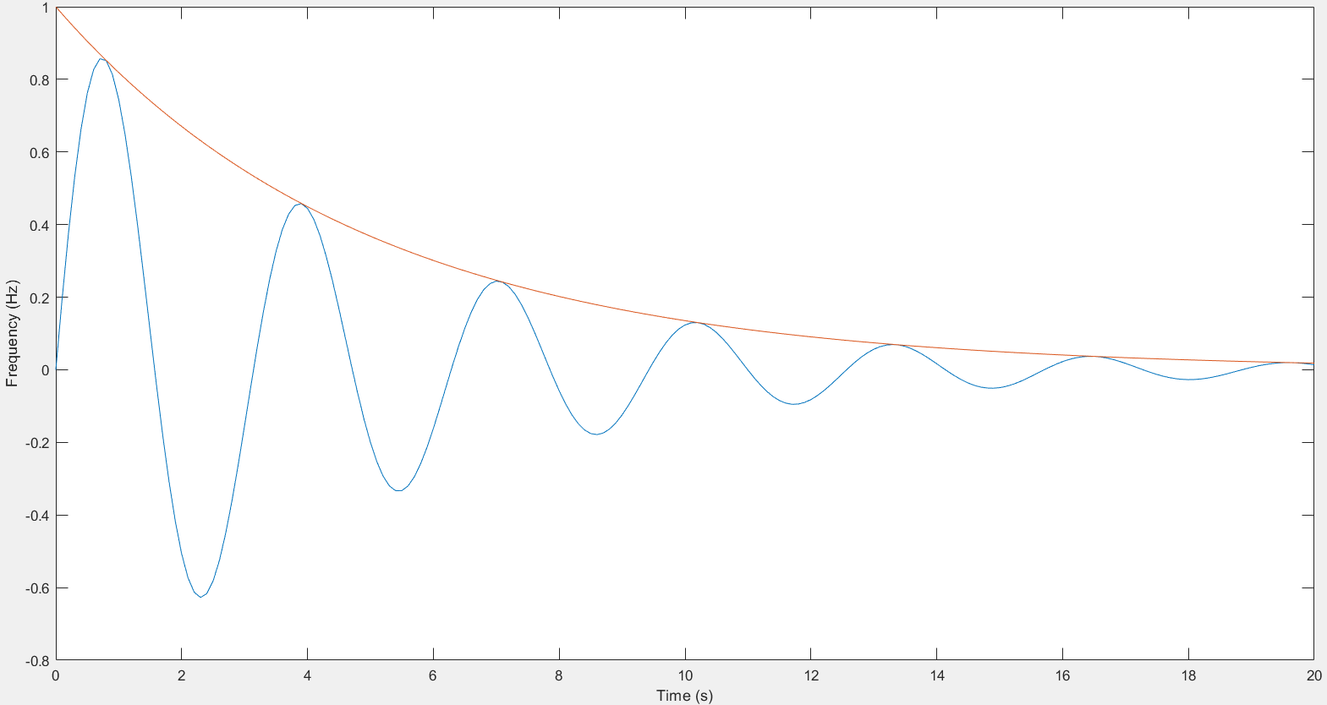

|  |  |
| --- | --- |
| **1. INTRODUCTION** | **1.4 Thesis objectives & limitations: Evaluate the technical**  **characteristic of Push-rod suspension system** |

**Thesis’s objectives:**

|  |  |
| --- | --- |
|  | • Relationship between the wheel displacement and the Suspension travel  • The Spring stiffness and the Damping coefficient  • The change in Camber angle and sliding range of the tire |

**Idea:**

Compare with the Conventional suspension system under the same conditions:  
• Natural frequency  
• Damping ratio

|  |  |
| --- | --- |
| Ho Chi Minh University of Technology – 2022/05 | 7 |

|  |  |
| --- | --- |
| **1. INTRODUCTION** | **1.4 Thesis objectives & limitations: Evaluate the technical**  **characteristic of Push-rod suspension system** |

**Hypothesis:**

• Neglect the tire’s stiffness and sliding friction between tire and road

• Use vehicle’s mass of the conventional suspension system

**Limitations:**

• Not evaluate the frequency-weighted acceleration to calculate how intensive

vibrations affect human body

|  |  |  |
| --- | --- | --- |
| |  | | --- | | Ho Chi Minh University of Technology – 2022/05 | | 7 |

**STUDY ON AUTOMOTIVE PUSH-ROD SUSPENSION SYSTEM**

CONTENTS

|  |  |  |  |  |  |
| --- | --- | --- | --- | --- | --- |
| |  | | --- | | **1** | | Introduction | **2.1** | Kinematic problem |  |
| |  | | --- | | **2** | | **Key problems** | **2.2** | Dynamic problem |  |
| |  | | --- | | **3** | | Implementation process | |  |  |
| |  | | --- | | **4** | | Result and disscussion | |  |  |
| |  | | --- | | **5** | | Conclusion and future work | |  |  |
|  | Ho Chi Minh University of Technology – 2022/05 | |  | 8 |

|  |  |  |
| --- | --- | --- |
| **2. KEY PROBLEMS** | **2.1 Kinematic problems** |  |
| Relationship between wheel  displacement and suspension travel | |

𝛾

|  |  |  |  |
| --- | --- | --- | --- |
| Kinematic | The change in camber angle |  |  |
| problems | Sliding range between road and tire |  |  |
|  |
|  | |  | | --- | | Ho Chi Minh University of Technology – 2022/05 | |  | 9 |

|  |  |
| --- | --- |
| **2. KEY PROBLEMS** | **2.2 Dynamic problem** |

Spring stiffness

|  |  |
| --- | --- |
| Dynamic | Damping coefficient |
| problems |  |

Natural frequency and damping ratio

|  |  |
| --- | --- |
| Ho Chi Minh University of Technology – 2022/05 | 10 |

**STUDY ON AUTOMOTIVE PUSH-ROD SUSPENSION SYSTEM**

CONTENTS

|  |  |  |  |  |
| --- | --- | --- | --- | --- |
| |  | | --- | | **1** | | Introduction | **3.1** | Build 3D model on SolidWorks |
| |  | | --- | | **2** | | Key problems | **3.2** | Simulate on Matlab/Multibody |
| |  | | --- | | **3** | | **Implementation process** | **3.3** | Road profile simulation |
| |  | | --- | | **4** | | Result and disscussion | **3.4** | Calculation flow |
| |  | | --- | | **5** | | Conclusion and future work | |  |
|  | Ho Chi Minh University of Technology – 2022/05 | | 11 |

|  |  |  |  |  |  |  |  |  |
| --- | --- | --- | --- | --- | --- | --- | --- | --- |
| **3. IMPLEMENTATION PROCESS** | | | **3.1 Build 3D model on SolidWorks** | | | | |  |
|  | | | | **Spring and** | |  | |
| **damper** | |
|  |
| **Camber angle** | |
| **and sliding of tire** | |
| **Translational** | |  |
| **base** | |
|  |
| |  | | --- | | **Fix base** | | |
| *Fig 7: 3D model of Push-rod suspension system* | | | | *Fig 8: 3D model of Conventional suspension system* | |
| |  | | --- | | **Parameters** | | |  | | --- | | **Unit** | | |  | | --- | | **Meaning** | | | | |  | | --- | | **Value** | | | |  |
| |  | | --- | | 𝑚𝑠1 | | |  | | --- | | Kg | | |  | | --- | | Sprung weight (1/3 load) | | | | |  | | --- | | 574 | | | |  |
| |  | | --- | | 𝑚𝑠2 | | |  | | --- | | Kg | | |  | | --- | | Sprung weight (2/3 load) | | | | |  | | --- | | 706 | | | |  |
| |  | | --- | | 𝑚𝑠3 | | |  | | --- | | Kg | | |  | | --- | | Sprung weight (full load) | | | | |  | | --- | | 840 | | | |  |
| |  | | --- | | 𝑚𝑢 | | |  | | --- | | Kg | | |  | | --- | | Unsprung weight | | | | |  | | --- | | 80 | | | *Table 1: light truck suspension parameters* |
| *(Source: Vibration analysis of a light truck by 3d* |
| |  | | --- | | 𝑘𝑠 | | |  | | --- | | N/m | | |  | | --- | | Spring stiffness | | | | |  | | --- | | 28566 | | | *dynamic vehicle vibration model by Mr. Truong* |  |
| |  | | --- | | 𝑐𝑠 | | |  | | --- | | Ns/m | | |  | | --- | | Damping coefficient | | | | |  | | --- | | 2090 | | | *Hoang Tuan, Dr. Tran Huu Nhan and Mr. Tran* |
| *Quang Lam.)* |
| Ho Chi Minh University of Technology – 2022/05 | | | | | | | | 12 |

|  |  |
| --- | --- |
| **3. IMPLEMENTATION PROCESS** | **3.2 Simulate on Matlab/Multibody** |

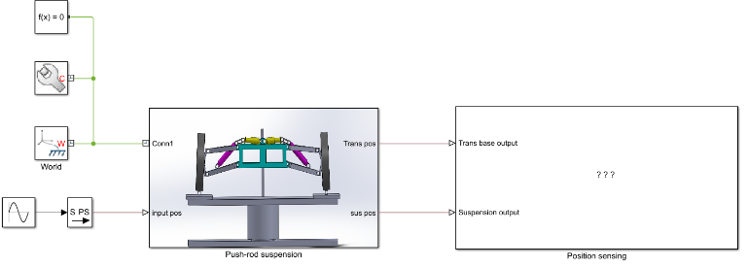

*Fig 9: Simulation model in Matlab/ Multibody environment*

|  |  |  |
| --- | --- | --- |
|  | **Simulation model** |  |
| **Mass (m)** | **Natural frequency (fn)** |
| **Spring stiffness (k)** | **Suspension system simulation on** | **Damping ratio (**𝜻**)** |
| **Damping coefficient (c)** | **Matlab/ Multibody** | **Dynamic deflection (**𝚫𝒙**)** |
| **Spring deformation** |

*Fig 10: Simulation input and output parameters*

|  |  |  |
| --- | --- | --- |
| |  | | --- | | Ho Chi Minh University of Technology – 2022/05 | | 13 |



|  |  |  |
| --- | --- | --- |
| **3. IMPLEMENTATION PROCESS** | **3.3 Road profile simulation** | |
|  | |  |

*Fig 11: Harmonic road profile simulation on Matlab/ Multibody*

Natural frequency of the simulation model

Using harmonic road profile to find

The Gain response spectrum

|  |  |  |
| --- | --- | --- |
| |  | | --- | | Ho Chi Minh University of Technology – 2022/05 | | 14 |

|  |  |
| --- | --- |
| **3. IMPLEMENTATION PROCESS** | **3.4 Calculation flow** |

Start

|  |  |  |  |  |  |  |  |
| --- | --- | --- | --- | --- | --- | --- | --- |
| input_f + 0.01 | |  | | --- | | **Setup variables**: sus_stiffness sus_damp input_amplitude Spring_deformation | | |  |  |  | | --- | --- | --- | | FALSE | |  | | --- | | plot(gain_res) | | |  |
| |  | | --- | | input_f = 0.01:0.01:20 | |
| input_f <20 |
| TRUE |

|  |
| --- |
| - sim('push_rod_final_assem') / sim(‘conventional_final_asssem’)- Calculate max value of push-rod oscillation amplitude - Calculate the gain between push-rod and translational base oscillation amplitude - Create vector of gain response: gain_res |

*Fig 12: Calculation flowchart of the simulation model*

|  |  |  |
| --- | --- | --- |
| |  | | --- | | Ho Chi Minh University of Technology – 2022/05 | | 15 |

**STUDY ON AUTOMOTIVE PUSH-ROD SUSPENSION SYSTEM**

CONTENTS

|  |  |  |  |  |
| --- | --- | --- | --- | --- |
| |  | | --- | | **1** | | Introduction | **4.1** | Relationship between wheel |
|  |
|  |  | | displacement and suspension |
| |  | | --- | | **2** | | Key problems | | travel |
| |  | | --- | | **3** | | Implementation process | **4.2** | Change in wheel alignment |
|  |
|  | **Result and disscussion** | **4.3** | and sliding gain |
| |  | | --- | | **4** | | Gain response spectrum |
|  |  |
| |  | | --- | | **5** | | Conclusion and future work | |  |
|  | Ho Chi Minh University of Technology – 2022/05 | | 16 |

|  |  |
| --- | --- |
| **4. RESULT & DISSCUSSION** | **4.1 Relationship between wheel displacement and suspension travel** |

**Relationship between Wheel displacement and Suspension travel**

250

|  |  |  |  |  |  |  |  |  |  |
| --- | --- | --- | --- | --- | --- | --- | --- | --- | --- |
| Wheel displacement (mm) | -60 | -40 | -20 | 200 | 0 | 20 | 40 | 60 | Push-rod suspension |
| 150 |
| 100 |
| 50 |
| 0 |
| -50 | Conventional suspension |
| -100 |

-150

-200

Suspension travel (mm)

*Fig 13: Relationship between wheel displacement and suspension travel curve*

|  |  |
| --- | --- |
| - | Suspension travel of the Push-rod suspension system is 25 mm shorter than Conventional suspension |

→ **Use shorter suspension system**

|  |  |
| --- | --- |
| - | Maximum and minimum wheel displacement of Push-rod suspension is 70mm and 50mm lower than Conventional suspension respectively |

→ **Decrease the dynamic deflection, reduce the movement of vehicle’s body**

|  |  |
| --- | --- |
| Ho Chi Minh University of Technology – 2022/05 | 17 |

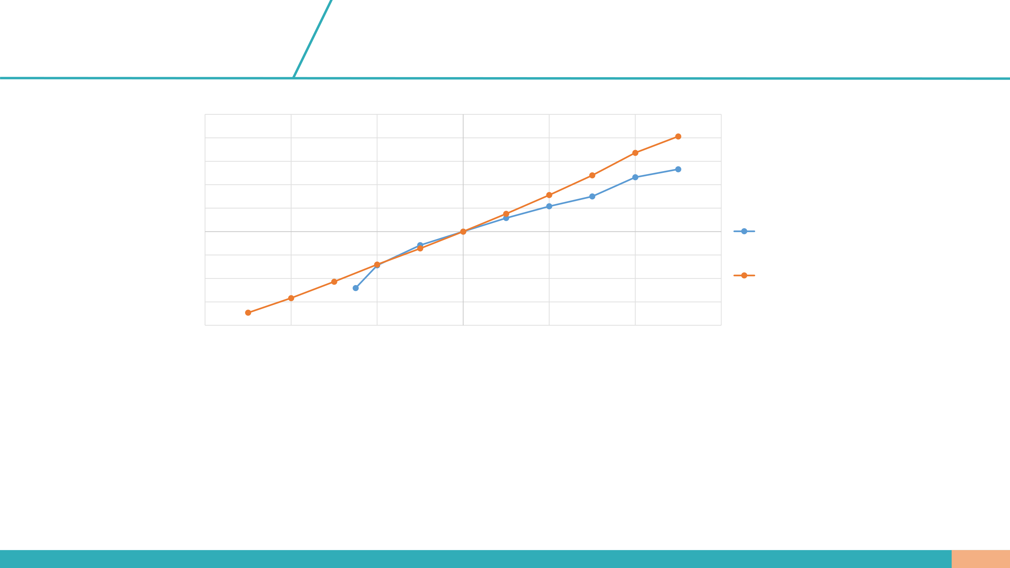

|  |  |
| --- | --- |
| **4. RESULT & DISSCUSSION** | **4.2 Change in camber angle and sliding range** |

**Relationship between the camber angle and sliding range**

|  |  |  |  |  |  |  |  |  |  |  |  |
| --- | --- | --- | --- | --- | --- | --- | --- | --- | --- | --- | --- |
| 30  25  Sliding range (mm)  20  15  10  5 | |  |  |  | | --- | --- | --- | | 20 |  |  | | 15 |  | Conventional suspension system | |  | | 10 |  | Push-rod suspension system |   Sliding range (mm) |

0

|  |  |  |  |  |  |  |  |  |
| --- | --- | --- | --- | --- | --- | --- | --- | --- |
| 0 | 1 | 2 | 3 | 4 | 5 | 6 | 7 | 8 |

Camber angle (Degree)

*Fig 14: Relationship between change in camber angle and tire's sliding range curve*

|  |  |  |  |
| --- | --- | --- | --- |
| -  - | |  |  | | --- | --- | |  | Camber angle of both suspension system vary from 2° to 7°  The sliding rang of the tire of the Push-rod suspension system is always lower when the camber angle change, about 4 mm lower |   -  - |

→ **Less tire slip compared with the conventional suspension system**

|  |  |  |
| --- | --- | --- |
| |  | | --- | | Ho Chi Minh University of Technology – 2022/05 | | 18 |

|  |  |  |  |  |  |  |  |
| --- | --- | --- | --- | --- | --- | --- | --- |
| **4. RESULT & DISSCUSSION** | | | **4.3 Gain response of the vehicle** | | | |  |
|  | | | |  | | |
| *Fig 15: Gain response spectrum of 1/3 load condition* | | | | *Fig 16: Gain response spectrum of 2/3 load condition* | | |
| **1/3 load**: m = 574 kg | | | | **2/3 load:** m = 706 kg | | |
| **Natural frequency:** | | | | **Natural frequency:** | | |
| • | Push-rod: | fn = 1.62 Hz | | • | Push-rod: | fn = 1.15 Hz |
| • | Conventional: fn = 1.25 Hz | | | • | Conventional: fn = 1.17 Hz | |
| **Damping ratio:** | | 𝜁 = 0.259 | | **Damping ratio:** 𝜁 = 0.249 | | |
| |  | | --- | | Ho Chi Minh University of Technology – 2022/05 | | | | | | | | 19 |

|  |  |  |  |  |
| --- | --- | --- | --- | --- |
| **4. RESULT & DISSCUSSION** | **4.3 Gain response of the vehicle** | | | |
|  | | **Full load:** m = 840 kg **Natural frequency:** | | |
| • | Push-rod: | fn = 1.09 Hz |
| • | Conventional: fn = 1.02 Hz | |
| **Damping ratio:** | | 𝜁 = 0.274 |

*Fig 17: Gain response spectrum of full load condition*

|  |  |  |
| --- | --- | --- |
| |  | | --- | | Ho Chi Minh University of Technology – 2022/05 | | 20 |

|  |  |  |  |  |  |  |  |  |
| --- | --- | --- | --- | --- | --- | --- | --- | --- |
| **4. RESULT & DISSCUSSION** | | **4.3 Gain response of the vehicle** | | | | |  | | --- | | **Full load** | | |
| |  | | --- | | **1/3 Load** | | | | | |  | | --- | | **2/3 load** | | |
| |  | | --- | | **Suspension** | | |  | | --- | | Push-rod | | | |  | | --- | | Conventional | | |  | | --- | | Push-rod | | |  | | --- | | Conventional | | |  | | --- | | Push-rod | | |  | | --- | | Conventional | |
| |  | | --- | | **Natural frequency** | | |  | | --- | | 1.62 | | | |  | | --- | | 1.25 | | |  | | --- | | 1.15 | | |  | | --- | | 1.17 | | |  | | --- | | 1.02 | | |  | | --- | | 1.09 | |
| |  | | --- | | **Damping ratio** | | |  | | --- | | 0.259 | | | |  | | --- | | 0.259 | | |  | | --- | | 0.249 | | |  | | --- | | 0.249 | | |  | | --- | | 0.274 | | |  | | --- | | 0.274 | |

*Table 2: Natural frequency and damping ratio of Push-rod and Conventional suspension system with different load condition*

|  |  |  |  |  |  |
| --- | --- | --- | --- | --- | --- |
|  | |  | | --- | | **Push-rod** | | |  | | --- | | **Conventional** | | **Difference** |
| |  | | --- | | **Spring stiffness (N/m)** | | |  | | --- | | 36500 | | |  | | --- | | 28566 | | 1.27 times |
| |  | | --- | | **Damping coefficient (Ns/m)** | | |  | | --- | | 3034 | | |  | | --- | | 2090 | | 1.45 times |

*Table 3: Spring stiffness and damping coefficient of Push-rod and Conventional suspension system*

|  |  |  |  |
| --- | --- | --- | --- |
| -  - | |  |  | | --- | --- | |  | When the load increases from 1/3 to full load → the Natural frequency decreases moderately and the damping ratio fluctuate from 0.249 to 0.274  The Spring stiffness and Damping coefficient of the Push-rod suspension system is 1.27 times and 1.45 times greater than Coventional suspension system respectively |   -  - |

→ **Use a spring with higher stiffness**

|  |  |
| --- | --- |
| Ho Chi Minh University of Technology – 2022/05 | 21 |

**STUDY ON AUTOMOTIVE PUSH-ROD SUSPENSION SYSTEM**

CONTENTS

|  |  |  |  |
| --- | --- | --- | --- |
| |  | | --- | | **1** | | Introduction |  |
| |  | | --- | | **2** | | Method and core solution |  |
| |  | | --- | | **3** | | Implementation process |  |
| |  | | --- | | **4** | | Result and disscussion |  |
| |  | | --- | | **5** | | **Conclusion and future work** |  |
|  | Ho Chi Minh University of Technology – 2022/05 | 22 |

**5. CONCLUSION & FUTURE WORK**

|  |  |  |  |  |  |  |  |  |  |  |  |
| --- | --- | --- | --- | --- | --- | --- | --- | --- | --- | --- | --- |
| - | **CONCLUSION** | | | | | | | | | - | **FUTURE WORKS** |
| Push-rod suspension has more linkage components | | | | | | | | | Optimize the design of Push rods and the |
| - | Shorter | | suspension | | travel | and | movement | | of | - | rocker arms. |
| Study the relationship between ride comfort |
| vehicle’s body | | | | | | | | |
| - | Spring stiffness and damping coefficient is greater | | | | | | | | | - | and handling of vehicle. To achieve this, a 3D |
| suspension model is utilized to consider the |
| than conventional suspension system | | | | | | | | | vehicle rotational motions. |
| - |
| Simulation method compared with calculus method: | | | | | | | | | Evaluate the frequency-weighted acceleration |
| • | Combination of vertical and horizontal direction | | | | | | | | to calculate how intensive vibrations affect |
| • | Use | various | linkage | | components | | in | the | human body |

simulation model

|  |  |  |  |
| --- | --- | --- | --- |
| - | Advantages of Push-rod suspension: | |  |
| • | Better aerodynamic by optimizing the push-rod |
| design | |
| • | |  |  | | --- | --- | |  | More stable when heavy cornering |   • |
|  | |  | | --- | | Ho Chi Minh University of Technology – 2022/05 | | | 23 |

**References**

|  |  |
| --- | --- |
| [1]  [2]  [3]  [4]  [5]  [6]  [7]  [8] | Georg Rill (2012), Road Vehicle Dynamics: Fundamentals and Modeling, CRC Press.  MathWorks, Student competition programs, MathWorks Support for Student Competitions https://www.mathworks.com/academia/student-competitions.html  Truong Hoang Tuan, Tran Huu Nhan, Tran Quang Lam (2015). Vibration analysis of a light truck by 3ddynamic vehicle vibration model, Science and Technology Development Journal.  Thomas D. Gillespie (1992), Fundamentals of Vehicle Dynamics, Society of Automotive Engineers.  Figure of Push-rod suspension system at https://suspensionsguy.wordpress.com/2020/08/02/example-post-3/  Figure of Positive and Negative camber angle at https://cartreatments.com/what-is-camber/  Bayer, Andrew (May 2009). Adjustable Pushrod Suspension Design (PDF) (Thesis). University of Cincinnati.  Karthik.S, Krupa R, Smruti Rekha Sen. (2016). "Design and Analysis of a Pushrod Suspension System for aFormula Racing Car" (PDF). Technical Research Organisation India. |



|  |  |  |  |
| --- | --- | --- | --- |
| |  |  | | --- | --- | |  |  | |  |